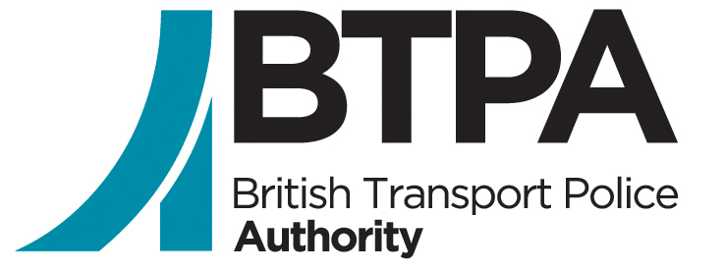

Requesting a Review Against the Outcome of your Complaint Form

Using this form:
Please use this form if you are unhappy about the outcome of your complaint, or feel it was not reasonable or proportionate, you have the right to have it reviewed.

The BTPA must receive your request for a review within 29 days from the day after the date stated on your outcome letter. This includes the time your request for a review is in the post. By completing this form you are giving us permission to access your complaint case to carry out the review.

How will my review be carried out?
In line with the Independent Office of Police Conduct (IOPC) statutory guidance the review will not be a reinvestigation of your complaint, but rather to consider if the outcome that was given to you was reasonable and proportionate. Further information and a copy of the statutory guidance can be found on the IOPC’s website - https://www.policeconduct.gov.uk/
Accessibility
If it is difficult for you to use this form or this service – for example, if English is not your first language or you have a disability – please contact us:
Telephone: 07900 394397
Email: btpa-enquiries@btp.police.uk
If you require any adjustments to support you through the complaints system, please outline these below. For example, if you have a visual impairment, you may require the police or other organisation to provide written responses in larger text.
What happens to the information in my review form?
The information you provide on this form will be entered into our systems. Please note, all the contents of this form (including your equality and diversity information) may be passed on to the relevant police force/organisation. For information about how we handle your personal information, please read our privacy notice at https://btpa.police.uk/livesite/wp-content/uploads/2018/10/BTPA-Data-Protection-Privacy-Notice.pdf
Where to send this review and appeal form
This form should be completed and sent to the BTPA by
Email: btpa-enquiries@btp.police.uk
Mail: British Transport Police Authority, 25 Camden Road, London, Bridge Street, London, NW1 9LN
To assist us in undertaking your review, please provide as much detail as possible in the boxes below.

Section 1 - About you
*Title:
*First name(s):
*Last name(s):
Date of birth:
Please provide at least two forms of contact below.
Address:
Email:
Telephone:
Preferred method of contact:
Are you applying for a review for someone else? If the answer is no, you do not need to complete Section 2.

Section 2 – Details of person on whose behalf you are applying for a review
Do not complete this section, if you are applying for a review on your own behalf.
If you are applying for a review on behalf of someone else, you must have permission from that person.
What is your relationship to the person applying for a review?
*Title:
*First name(s):
*Last name(s):
Date of birth:
Please provide at least two forms of contact below.
Address:
Email:
Telephone:
Preferred method of contact:

Section 3 – Review details
Please attach the final decision letter from the British Transport Police or any additional documents that are relevant.

Force reference number: This should be on any correspondence you have had from British Transport Police.
Please explain why you want to apply for a review. Please outline if you are unhappy with the way your case was recorded or handled, the way it was investigated or the outcome of the case. Please provide details explaining why.

Please explain what you would like to happen. If you are unhappy with the outcome of your complaint or the way it was investigated, you may want to suggest an alternative outcome.

Section 4 – Confirmation that information provided is correct
I confirm the information I have provided is truthful and accurate to the best of my knowledge.
Name:
Date:

Section 5 – Equality of service monitoring form
We want to make sure everyone has an equal chance to use and benefit from our services. To ensure we continue to do this, it would help us if you could answer the following questions. If you prefer, you do not have to answer these questions as it will not affect your appeal in any way.
The information provided in this form will be used by public bodies involved in the police complaints system, including the police and IOPC. You can find out how your personal information will be used in the privacy notices found on the website of each organisation.

Please mark all the answers that apply with an ‘X’.

Sex:
Female
Male
Intersex
Other (please give details)
Is your gender different to the gender you were assigned at birth?
Yes
No
Don’t know
If yes, please state the gender you were assigned at birth:

Sexual orientation:
Heterosexual/ straight
Bisexual
Gay/lesbian
Not known
Other (please state below)
Do you have a physical or mental impairment that has a substantially adverse and long-term effect on your ability to carry out normal day-to-day activities?
Yes
No
Don’t know
If you have answered 'yes' to the question above, which option below describes your disability?
Hearing
Learning difficulty
Long standing illness or health condition
Mental health condition
Mobility or physical impairment
Sight
Other (please state below)
Ethnicity:
White: English/Welsh/Scottish/Northern Irish/British
White: Irish
White: Gypsy, Traveller or Irish Traveller
White: any other white background (please describe)
Mixed: white and black Caribbean
Mixed: white and black African
Mixed: white and Asian
Mixed: any other mixed/multiple ethnic background (please describe)
Asian: Indian
Asian: Pakistani
Asian: Bangladeshi
Asian: Chinese
Asian: any other Asian background (please describe)
Black: African
Black: Caribbean
Black: any other black/African/Caribbean background (please describe)
Other: Arab
Not known
Other: any other ethnic group (please describe)
Religious belief/faith:
No religion
Christian (including Church of England, Catholic, Protestant and all other Christian denominations)
Buddhist
Hindu
Jewish
Muslim
Sikh
Any other religion (please describe)
Not known

Pregnancy and maternity:
Pregnant
On maternity/paternity/adoption leave
Returning from maternity/paternity/adoption leave
None of the above

Thank you for the information you have provided.

End of form.

This form should be completed and sent to the BTPA by
Email: btpa-enquiries@btp.police.uk
Mail: BTPA 25 Camden Street, London NW1 9LN

